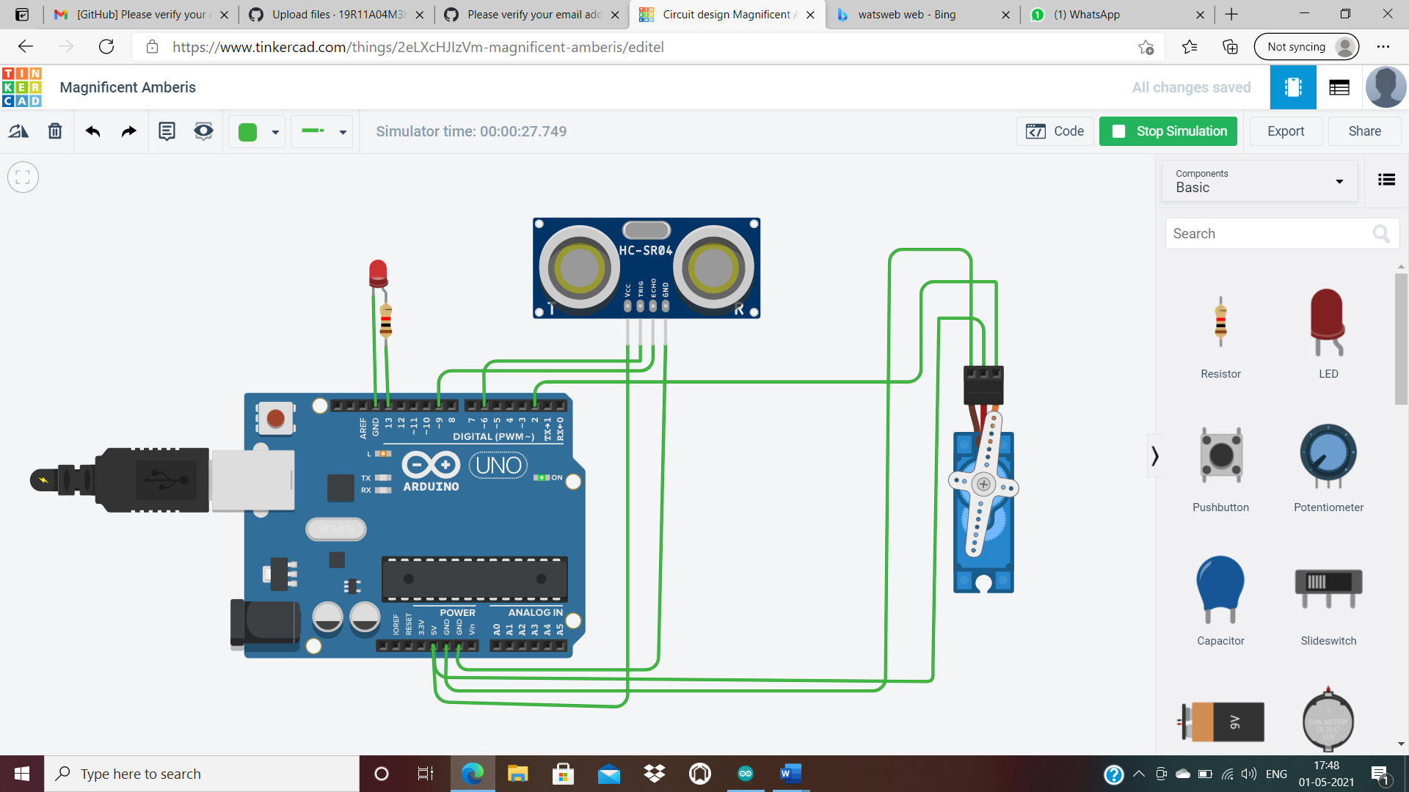#include<Servo.h>

int trigpin=6;

int echopin=9;

int ledpin=13;

Servo motor;

void setup()

{

pinMode(trigpin,OUTPUT);

pinMode(echopin,INPUT);

pinMode(ledpin,OUTPUT);

Serial.begin(9600);

motor.attach(2);

}

void loop()

{

digitalWrite(trigpin,HIGH);

delay(1000);

digitalWrite(trigpin,LOW);

delay(1000);

int duration=pulseIn(echopin,HIGH);

int distance=(duration\*0.034)/2;

Serial.print("distance");

Serial.println(distance);

if ((distance>=50)&&(distance<350)){

motor.write(90);

Serial.println("angle is 90");

digitalWrite(ledpin,HIGH);

delay(1000);

}

else if(distance<50){

motor.write(180);

Serial.print("angle is 180");

delay(1000);

digitalWrite(ledpin,HIGH);

}

else

{

motor.write(0);

Serial.print("angle is 0");

delay(1000);

digitalWrite(ledpin,LOW);

}

}